**The Lowdown on OmniScripts**

An OmniScript gives customers a guided path for completing a business process and serves as a configurable way of creating a seamless customer experience (which is *always* a good thing). In the following image, you see an OmniScript walking a customer through several steps to select an insurance policy. First they provide home details, then they select standard coverage packages. They are then prompted to select customizations for the packages. After all of this, they view their proposal for coverage. If they accept the proposal, they can complete the transaction and activate their coverage.

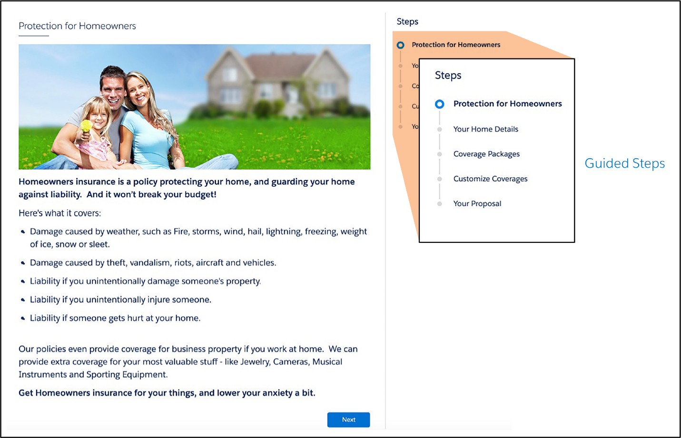

Here are a few other instances of when you might use OmniScripts.

* A customer service agent adds a new customer and captures details for a service implementation, such as network configuration requirements.
* A customer steps through a selling process, such as choosing a new insurance plan.
* An insurance agent updates a policy.
* A customer completes a self-service interaction such as troubleshooting a service outage.
* A customer completes forms for different services, such as government benefits, insurance policies, and healthcare coverage.

With an OmniScript, you configure interactive business processes that are easy to use, yet have complex functionality occurring behind the scenes. OmniScripts also have built-in branching capability, which means they show different pages and groups of fields based on choices the user makes. For the customer, this translates into a dynamic and personalized experience.

## Key Capabilities

**Build OmniScripts Quickly with Drag and Drop and Low to No Code**

OmniScript is a declarative scripting tool you create with clicks, not code. Using the OmniScript Designer, you drag and drop items to build the structure of the OmniScript, then preview and debug your work using the built-in troubleshooting tools.

this means you can quickly create and easily maintain OmniScripts, which saves lots of time.

**Use OmniScripts on Any Device and Any Channel**

OmniScripts are not restricted to OmniStudio Interaction Consoles for agents to use. You can deploy them on any device and any channel, such as a mobile device, or a consumer portal. Here’s what an OmniScript looks like when viewed on a mobile device and online.

Being able to view the same OmniScript on multiple channels without having to change the configuration is another time-saver!

**OmniScripts Have Modular Architecture**

An OmniScript’s look and feel (frontend) is separated from its functionality (backend). OmniScripts separate the JavaScript Object Notation (JSON) metadata structure (1), the stylesheets (2), and the data (3) from each other.

This modular architecture supports prototyping and building the user experience quickly. It also promotes using data from anywhere, reuse of JSON metadata, and ease in applying branding standards.

**Display Data from Multiple Data Sources**

An OmniScript can display both internal data from Salesforce and external data from a website or a third-party legacy system.

OmniScript’s data-oriented Actions elements call application programming interfaces (APIs), OmniStudio Integration Procedures, and other tools to access data from anywhere. You integrate data from multiple sources (Salesforce or third-party), manipulate the data, and send it back to its source, all from within the OmniScript. The data is captured in the standard JSON format.

Client-side execution improves performance and reduces API calls.

**Rebrand OmniScripts to Suit Your Customers**

You can control both the style and appearance of OmniScripts. You change the appearance of an OmniScript two ways. First, by using custom Lightning stylesheets to determine whether the guided interaction has a horizontal or vertical mode, branding, or any other aspects you wish to see. Second, by using the Newport Design System (NDS). NDS includes a complete set of customizable, global styles and is a Cascading Style Sheets (CSS) framework. It lets designers and web developers easily restyle all of their OmniStudio components in a single place and generate a custom, optimized CSS file that can be used in all future pages. It can even be used for non-OmniStudio and non-Salesforce pages.

**Manage Signed Documents with OmniScripts**

You can create dynamic documents from templates (MS Word, PDF, and HTML outputs), merge data from any data source (for example, Salesforce objects, or user inputs such as sales quotes, order forms, and contracts), and then create and operate on these documents within OmniScripts. You attach them to Salesforce records and email them to recipients, plus delegate to DocuSign for eSignatures. The signed document received from DocuSign is automatically attached back to the latest version of a contract.

## Get a Little Guidance from OmniScripts

OmniScript guided interactions do exactly what their name suggests: They guide users through sales and service processes, enabling them to quickly and easily achieve their goals. These interactions are dynamic, agile, scalable—and often personalized—creating customer experiences that are engaging and efficient.